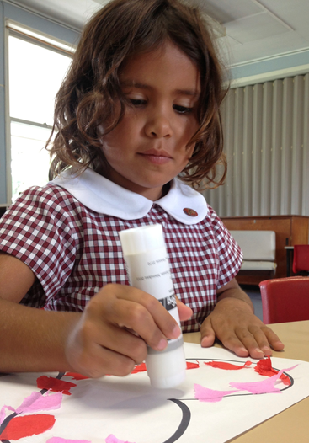
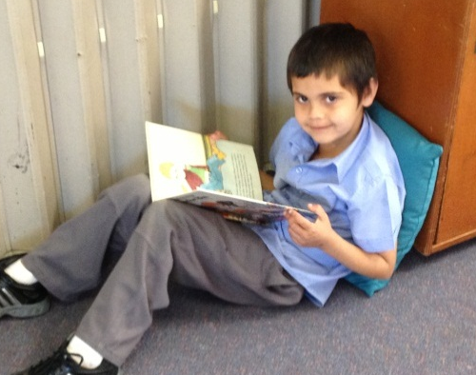
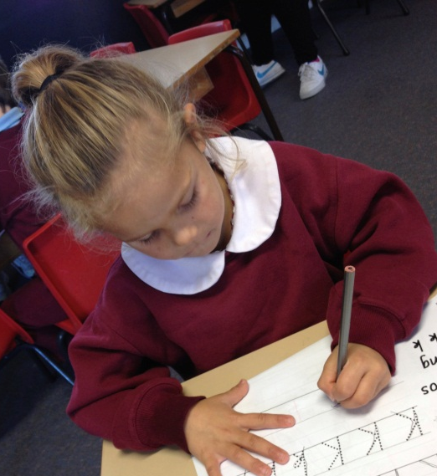
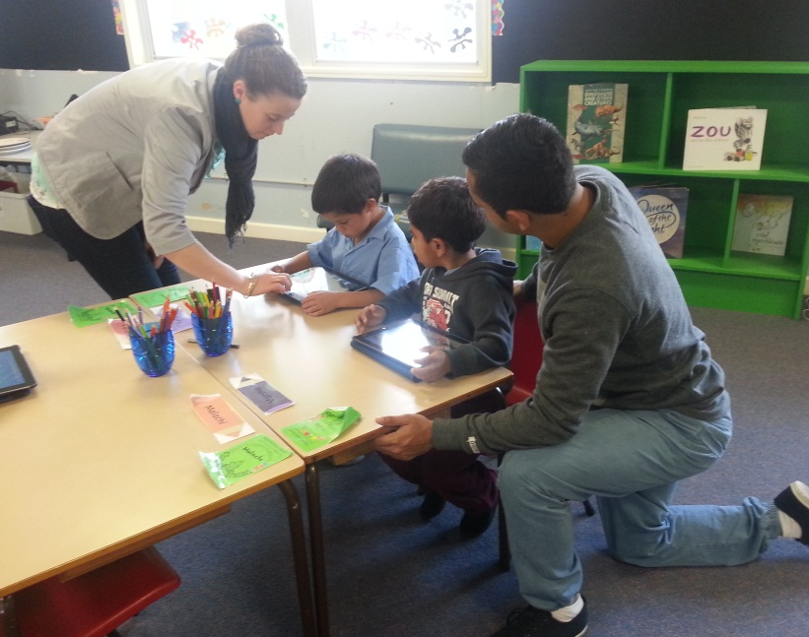

Moree East Public School
Annual School Report

4118

School Context
Moree East Public School is a P5 Primary School with a student enrolment that fluctuates between 140-150 students. 89% of the student body identifies as Aboriginal. Moree East Public School services the students of South and South East Moree.

Principal’s Message
Moree East Public School is very close knit, school community that promotes a culture of excellence. The implementation of core programs in the areas of Literacy, Numeracy and Student Engagement, ensure a consistent and systematic approach to achievement of student learning outcomes.

2013 was a very exciting time for Moree East PS. We began the implementation of the Connected Communities strategy and received the news that the school was to receive a major building upgrade, which is to commence early in 2014.

A massive achievement for the 2013 school year has been the stabilisation of school staff.
Permanent staff have been appointed to the school including two identified positions. These include the School Administrative Manager, School Administrative Officer, two classroom teachers and an Aboriginal Education Officer. The stabilisation of staff and delivery of quality educational programs have impacted positively on the school culture and supported improvements in student learning outcomes, attendance, engagement which has been supported through improved community engagement.

I certify that the information in this report is the result of a rigorous school self-evaluation process and is a balanced and genuine account of the school's achievements and areas for development.
Muriel Kelly
Executive Principal
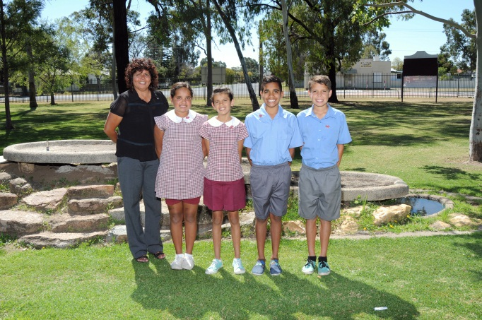

P & C and/or School Council message
A formal Parents and Citizens School Committee does not operate at Moree East PS, a collective decision made the school community parents. However, at Moree East PS a Sista’s group has been operational for 11 years and is an important contributor to our school, aiming to provide services and activities for our parents and students, plus additional educational resources for our school. This is achieved by fundraising activities, along with weekly luncheons for group members. All Sista group events and initiatives are supported by the staff and ensure successful community partnerships at each event. Whole school community events have included ‘Deadly Dads – Super Sons’, games afternoon and Marvellous ‘Mums – Deadly Daughters’, craft and beading activities. The group also donated to the school a much needed portable microphone system to support outdoor events.

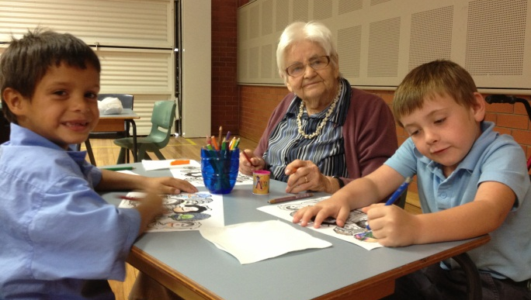

Breakfast Club
Breakfast club was operational from Monday – Friday during the time period, 8.00am to 8:50am for any child wishing to participate. Breakfast Club is sponsored by a number of investors besides the school’s global funding and the Schools as Community Centre. Investors include the Red Cross of Australia, Moree Community Links and Minister for Education, Adrian Piccoli. Breakfasts are served daily by a Schools as Community Centre worker on Tuesday, Wednesdays and Thursdays and breakfast is prepared by the Aboriginal Education Officer on Mondays and Fridays.

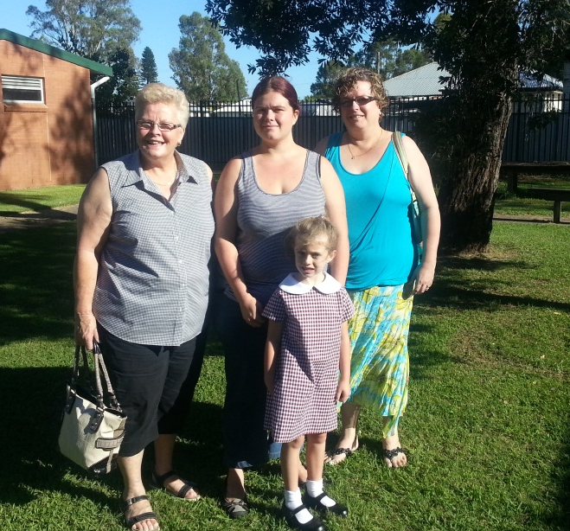

School Canteen
The school canteen is managed by the school and operated by Ms. Mandi Heaton. The canteen continues to receive enormous support from our parents and students. Throughout 2013 the canteen offered healthy lunch orders and counter sales each school day. The school canteen has not made profit during the 2013 school year and will be reviewed for 2014.
The canteen has been identified as a critical resource in the nutritional provision for students.

Student representative’s message
As 2013 school captains, we feel very lucky to be at Moree East Public School. As students of Moree East we have made excellent friends and it has been an honour to be a student leader and support each other. This year on behalf of Moree East Public School, we were honoured to meet Marie Bashir, the Governor of NSW. While we were with her, we talked about Aboriginal culture and about us becoming role models for younger students. Our duties have also included leading weekly assemblies, fundraising, and representing the school at different events.
Other important activities we were involved in were the ANZAC Day March, Remembrance Day and NAIDOC Day and representing the school in touch, rugby, swimming, cricket, athletics and dancing. We have also loved having the opportunity to go on excursions to places like Parliament House in Canberra, Dreamworld at the Gold Coast, and Currumbin Wildlife Sanctuary.
2013 School Captains

Student Information
It is a requirement that the reporting of information for all students be consistent with privacy and personal information policies.
Enrolments during 2013 increased which has resulted in an additional class being formed to support the learning needs of students. Enrolments numbers fluctuate due to student mobility. To support families returning to Moree the school supports families to return home through reenrollment and shared enrolments.

Student Enrolment Profile
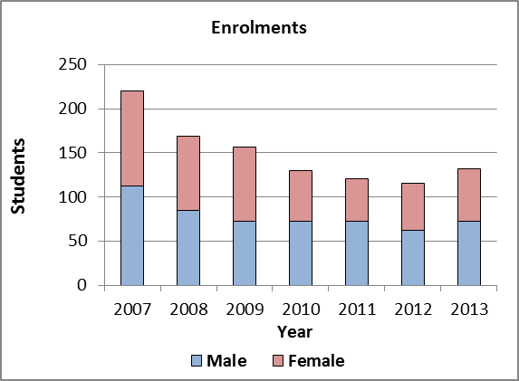

Student attendance profile

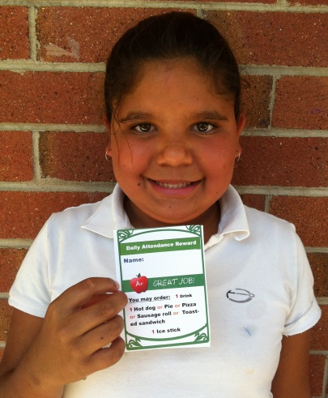
Attendance rate as of semester 1 was 74.7% which was an improvement on 2012 results.

Management of non-attendance
Attendance strategies were reviewed Term 3 with a strong improvement during term 4. Costs associated with rewards for improved attendance are validated as demonstrated through increased attendance rates for, Term 4, 2013.

Attendance budgets will be included in 2014 planning. Rewards include:
- Daily raffles
- Weekly prizes
- Term rewards
- Principal morning tea for improved student attendance.
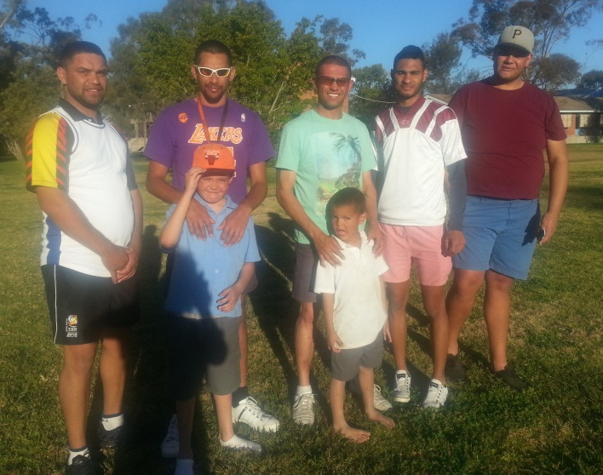

Workforce Information
It is a requirement that the reporting of information for all staff must be consistent with privacy and personal information policies.
Teaching and specialist staff retention at Moree East PS remains a continued focus, with a high priority to secure stability of staff.
Staffing Allocation
In 2013, 3.4 teaching positions were funded under the National Partnerships Equity funding and Investing in Schools strategy.

Workforce composition
Position
Executive Principal | 1
Deputy Principal | 1
Assistant Principal | 1
Classroom Teacher(s) | 5
Primary Part Time Teacher | 0.3
Primary Teacher RFF | 0.252
Learning and Support Teacher(s) | 1.4
Teacher Librarian | 0.4
Home School Liaison Officer | 1
District Guidance Officer | 1
School Administrative & Support Staffupport Staff | 3.986
Total | 12.352
The Australian Education Regulation, 2013 requires schools to report on Aboriginal composition of their workforce.
Permanent Aboriginal Staff at Moree East PS includes the Executive Principal, two local Aboriginal classroom teachers, and two local Aboriginal Education Officers.
The School Administrative Manager, and School Administrative Officer positions became identified during 2013. These positions were successfully filled by two local Aboriginal women.

Teacher qualifications
All teaching staff meet the professional requirements for teaching in NSW public schools.
Qualifications | % of staff
Degree or Diploma | 100%

Financial Summary
This summary covers funds for operating costs and does not involve expenditure areas such as permanent salaries, building and major maintenance.
Date of financial summary | 30/11/2013
Income | $
Balance brought forward | 30/11/2013
Global funds | $
Tied funds | 228,109.01
School & community sources | 160,379.99
Interest | 811,252.83
Trust receipts | 26,781.95
Canteen | 10,459.22
Total income | 30,456.33
Expenditure | 49,630.24
Teaching & learning | 1,088,960.56
Key learning areas
Excursions
Extracurricular dissections | 21,946.61
Library | 10,023.21
Training & development | 30,903.08
Tied funds | 2,908.66
Casual relief teachers | 7,727.27
Administration & office | 365,013.32
School-operated canteen | 17,846.22
Utilities | 68,824.89
Maintenance | 65,868.76
Trust accounts | 99,952.65
Capital programs | 23,006.73
Total expenditure | 39,554.41
Balance carried forward | 1,795.50

A full copy of the school’s 2013 financial statement is tabled at the annual general meetings of the School Council and/or the parent body. Further details concerning the statement can be obtained by contacting the school.
Academic achievements
NAPLAN
In the National Assessment Program, the results across the Years 3, 5, 7 and 9 literacy and numeracy assessments are reported on a scale from Band 1 to Band 10.
The My School website provides detailed information and data for national literacy and numeracy testing (NAPLAN).
Click on the link http://www.myschool.edu.au
and enter the school name in the Find a school and select GO to access the school data.

NAPLAN Year 3 - Literacy (including Reading, Writing, Spelling and Grammar and Punctuation)
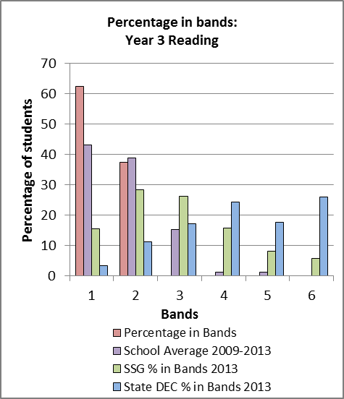
The percentage of students in Year 3 achieving at or above minimum standard in 2013 NAPLAN for Reading is 37.5%.

NAPLAN Year 5 - Literacy (including Reading, Writing, Spelling and Grammar and Punctuation)

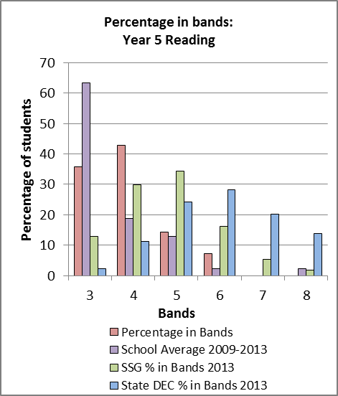

The percentage of students in Year 5 students achieving at or above minimum standard in 2013 NAPLAN for Reading is 64.3%. The target was exceeded by 29.3%.

NAPLAN Year 3 - Numeracy

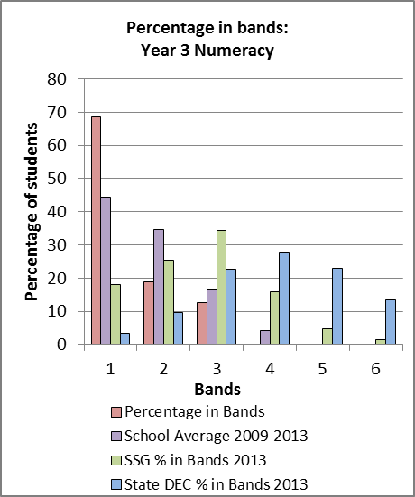
Students achieved less than expected growth.

NAPLAN Year 5 – Numeracy

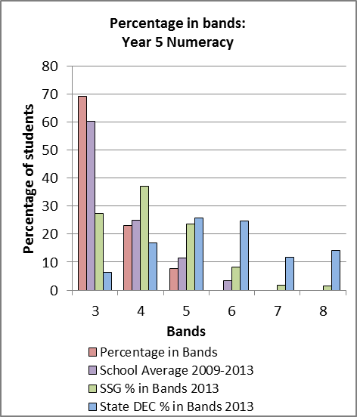

30.8% of Year 5 students were at or above minimum standard in Numeracy.

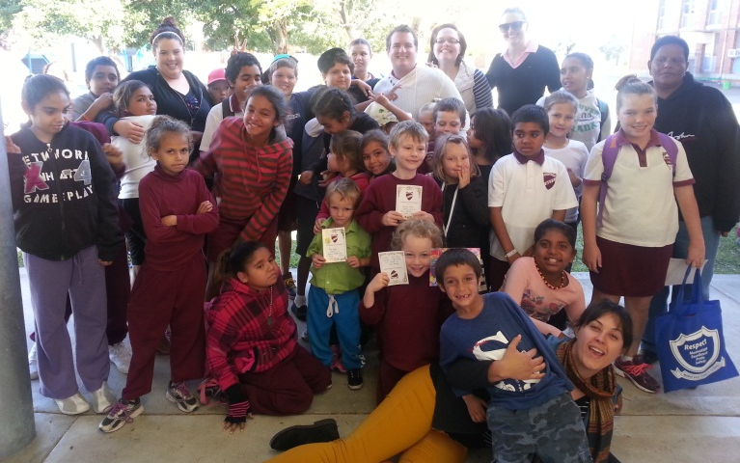

Significant Programs and Initiatives
Moree East Public School implements a variety of programs to develop and broaden student learning.

Connected Communities
Moree East PS is a Connected Community school which is part of the Connected Communities strategy. The strategy positions schools as community hubs. It broadens the influence of the community and school leadership, to play a role in the delivery of key services and in supporting children and young people from birth through school into further training, study and employment. Key features of the Connected Community strategy includes:
- Cultural awareness (Connecting to Country) delivered locally for all staff
- Teaching Aboriginal language and culture
- Additional school executive position – Leader: Community Partnerships
- Early years focus through to further learning and employment
- Personalised learning plans for all students
- Schools as a hub for service delivery
- Early intervention and prevention focus
- Partnership and co-leadership with the Aboriginal Community.

The strategy has been informed by advice from the Aboriginal Education Consultative Group (AECG), and will continue until 2018.

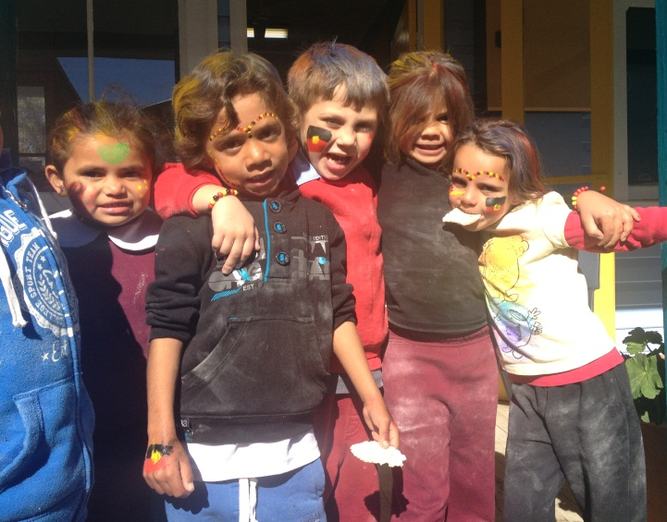
Positive Behaviour for Learning
Positive Behaviour for Learning (PBL) is a school-wide behaviour initiative currently in use at Moree East PS. PBL was introduced PBL encourages positive behaviour from students, which has been shown to improve their self-concept and motivation to learn. The Positive Behaviour for learning program commenced during 2011 and has remained embedded within our student welfare policies and programs to promote the Positive Behaviour for Learning model. All teachers are part of the school PBL team and students are rewarded daily for their commitment to the PBL values. The core expectations of PBL at Moree East are, be safe, be respectful, be motivated, and demonstrate pride, excellence and safety. The students at MEPS meet these expectations consistently at a very high level and show great pride in when receiving awards during weekly assemblies.
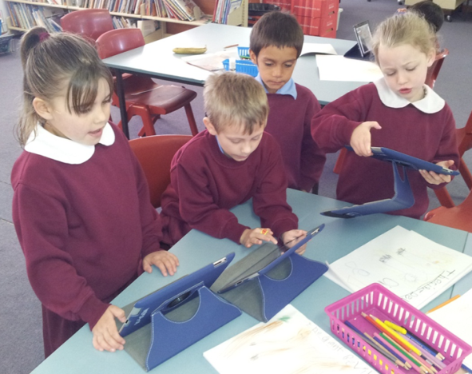

Aboriginal Education

Aboriginal education is a very high priority for Moree East Public School and cultural perspectives and connections with our community are applied to every aspect of the curriculum. As a Connected Community school we work in partnership with Aboriginal leaders in the local community to help improve education outcomes for young Aboriginal people. A unique feature of the Connected Communities strategy is the identification of local key stakeholders coming together to support the Executive Principal to implement the strategy. The Group provides a critical link to the wider school community which provides opportunities for shared decision-making about school needs which is reflected in the school plan. During 2013 the School Reference Group (SRG) worked closely together to establish terms of reference which will provide a basis for future school decision making. At Moree East PS, all students have Personalised Learning Plans (PLP’s) which are developed in consultation with parents, students and classroom teachers. These plans provide a basis for students to which highlight students short term and long term goals for the future.

NAIDOC Week

NAIDOC Week was a whole school community celebration across the week. An Assembly and flag raising ceremony kicked off the week where the meaning of and the importance of NAIDOC was shared across the school community. Awards were presented to students, staff and school community acknowledging their commitment and contribution to Aboriginal Education. It was followed by activities throughout the week and one included an activities day. On this day students and staff wore red, black and yellow, music echoed across the school, which was provided by James Smith, while students were engaged in cultural activities including making Jonny cakes screen printing, beading, arts and crafts. The week was a highly successful celebration due to parent and community participation and precise coordination by Mrs. Cutmore and Mrs French.

Norta Norta Program

Norta Norta funding was used to provide Aboriginal students not attaining National benchmarks with additional tuition in the areas of Literacy and Numeracy. Qualified tutors were employed to support reading groups and support targeted students in literacy and numeracy in Years 4 and 6.
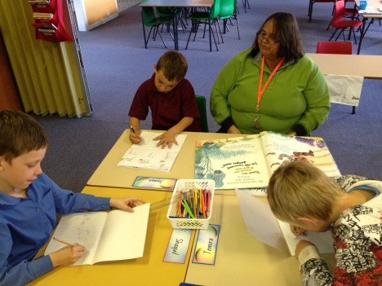

Multicultural Education
Multicultural Education is a valued component of the school’s curriculum as are the beliefs, customs and cultural backgrounds of all students enrolled in our school. Multicultural education is predominately taught through the key learning area of humans and Society in our environment.

Harmony Day
Harmony Day for 2013 saw each class learn all about a chosen country from around the world. These included Vietnam, South Africa, Italy, New Zealand, United States of America, Germany, India and Lithuania.
Throughout the weeks leading up to Harmony Day classes created projects, art displays, wrote reports, designed costumes and researched all about their country and its people. On Harmony Day each class cooked a traditional meal from their country, and we went on a “world tour” visiting each room, tasting the cuisine, admiring the class displays and learning more about how “everyone belongs” and make our world a better place by sharing their culture.
Easter Hat Parade
Moree East Public School was the talk of the town for our famous Annual Easter Hat Parade. Infant’s students smiled and giggled their way through the fun of dancing in front of the Primary students and all their family and friends.
K-2 students showed off their wonderful improvements in dance and performed the Chicken Dance, Heel and Toe Polka, Here We Go Round the Mulberry Bush and Side Shuffle from Ice Age. It was lovely to see the smiles on the student’s faces and to have so many parents at the parade. Aunty Jacqui was presented with a special Easter basket for her support in the infant’s classes. All students were very excited to meet the Easter Bunny and enjoyed enjoyed his eggs.
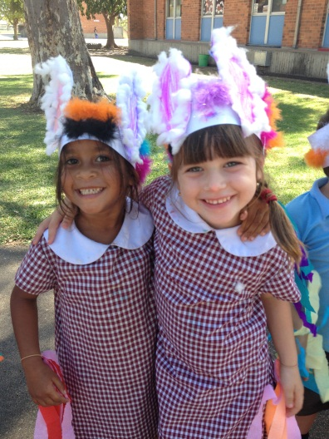

SPORT
Students at Moree East Public School were once again given a wide variety of sporting opportunities in 2013. Students competed in many PSSA sporting events, including Netball, Soccer, Touch Football and Rugby League. Standout performances include the boy’s touch football team who were crowned Regional Champions and State Quarter Finalist. The team competed at a state level and successfully achieved eighth place.

Participation in the zone and regional carnivals included the Swimming, Cross Country and Athletics.

Outstanding brothers and twins, Dwayne and Daniel Smith, gained selection in the Regional PSSA Touch Football team and also the Regional Rugby League football team. Trae Smith also gained selection in the regional Rugby League team.

I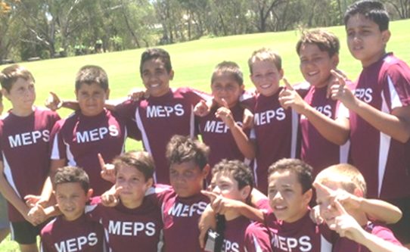

National Partnerships Program

Moree East has just completed its second year of the National Partnerships for Low SES Communities Government initiative. Through this partnership the school implemented a variety of actions across the six reforms in an effort to strengthen teaching practices and improve student learning and welfare.
The key strategies funded through the Low SES Communities National Partnership for 2013 were as follows.
Employment of a non-teaching, Assistant Principal, to mentor teachers in all aspects of Learning and Support and the employment of a School Learning Support Officer to provide additional in-class support for students.

School planning and evaluation 2012—2014

School evaluation processes
NSW public schools conduct evaluations to support the effective implementation of the school plan. The processes used include:

School planning 2012—2014: progress in 2013

Target 1‐ Literacy
Overall improvement in Growth and Performance for Literacy.

Outcomes from 2012–2014
*Decrease the percentage of students getting less than expected growth, from years 3 to 5, in Reading from 75% to 50%.

* Increase the percentage of Year 3 students achieving at or above the minimum standard (top
4 bands) in NAPLAN Reading from 43% in 2012 to
57% in 2013.

*Increase the percentage of Year 5 students achieving at or above the minimum standard
(top 4 bands) in NAPLAN Reading from 32% in
2012 to 50% in 2013.

Evidence of progress towards outcomes in 2013:
The percentage of students in Year 3 achieving at or above minimum standard in 2013 NAPLAN for Reading is 37.5%.
The percentage of students in Year 5 students achieving at or above minimum standard in 2013 NAPLAN for Reading is 64.3%. The target was exceeded by 29.3%.
100% of teachers expressed increased confidence in teaching reading.
100% of K-2 teachers implemented guided reading into their class programming
Professional learning for all K-2 teachers was provided by the schools instructional leader.
Target 2 ‐ Numeracy
Overall improvement in Growth and
Performance for Numeracy.

Outcomes from 2012–2014
*Decrease the percentage of students getting less than expected growth, from years 3 to 5, in Numeracy from 100% to 75%.

*Increase the percentage of students in Year 3
Achieving at or above the minimum standard (Top 4 bands) in NAPLAN Numeracy from 66%
In 2012 to 80% by 2013.

Increase the percentage of students in Year 3
Achieving at or above the minimum standard (Top 4 bands) in NAPLAN Numeracy from 69%
In 2012 to 88% by 2013.

Evidence of progress towards outcomes in 2013:
The Targeted Early Numeracy (TEN) program
was highly successful with 100% of students achieving positive progress of at least one level
on the Learning Framework in Number

30.8% of Year 5 students were at or above minimum standard in Numeracy.

All K-2 have completed TENS training and are implementing this into their class programming.

The district TENS advisor has supported the implementation of TENS through term visits.

Target 3- Engagement and Attainment
Increased levels of student engagement
through increased community involvement.

*Increase the average daily attendance from
78% to 80% by 2014.

*Decrease the number of students
with less than 80% attendance by
2%, by 2014.

Evidence of progress towards outcomes in 2013:
Whole school attendance rates improved to 74.7% during semester 1 of 2013.
Class rolls are marked daily by 9.30am
Daily home visits are performed by the Aboriginal Education Officer to support improved home school relationships and improved attendance.
100% of teachers are informed of attendance strategies.

Target 4- Leadership and Management
Build greater leadership capacity for
Improved school management.

* Increase the percentage of teachers
confident in the use of SMART data to
Inform planning and programming
From 50% to 90%.

*Increase the percentage of staff with
opportunities to develop leadership
capacity from 35% in 2011 to 80%
In 2012.

Evidence of progress towards outcomes in 2013:
100% of staff are more frequently discussing data during staff, stage and planning meetings.
100% of staff improved capacity to use data to drive their planning through consultation with the schools instructional leader.
100% of K-2 teachers use data to inform their planning during weekly planning meetings with the instructional leader.

Target 5- Aboriginal Education
Reduced gap in performance between
Aboriginal students and all students
In NAPLAN assessments.

* Decrease the percentage of Aboriginal students
getting less than expected growth, from Years
3 to 5,in Reading from 75% to 50%

Increase the percentage of Aboriginal students in
Year 3 achieving at or above the minimum standard in NAPLAN Reading from 43% in 2011
to 57% by 2012

*Increase the percentage of Aboriginal students in Year 5 achieving at or above the minimum standard in NAPLAN Reading from 32% in 2011
to 50% by 2012.

*Decrease the number of Aboriginal students with less than 80% attendance by 2% annually.

Evidence of progress towards outcomes in 2013:
100% of teachers are conducting the PLSP process with students and parents to establish future learning goals for students.
PLSPs are referred to by teachers to inform and review student goals during parent teacher interviews.
Parent participation during the planning process has increased with 50% more parents attending interviews.
Improved whole school attendance rates encompass the 92% Aboriginal student population.

About this report
In preparing this report, the self-evaluation committee has gathered information from evaluations conducted during the year and analysed other information about the school's practices and student learning outcomes. The self-evaluation committee and school planning committee have determined targets for the school's future development.
Muriel Kelly Executive Principal

School contact information
Moree East Public School
Adelaide Street Moree
NSW 2400
Ph: 02 6752 1733
Fax: 02 6752 1553
Email: moreeeast-p.school@det.nsw.edu.au
Web: www.moreeeast-p.schools.nsw.edu.au
School Code: 4118

Parents can find more information about Annual School Reports, how to interpret information in the report and have the opportunity to provide feedback about the report at:
http:// www.schools.nsw.edu.au/asr

